NCR 7895 Scanner/Scale
Follow the process outlined below to connect and configure the NCR 7895 Scanner/Scale for use with NCR Counterpoint.

Install NCR 7895 Scanner/Scale Drivers and 123Scan for NCR Utility
Follow these steps to install the NCR 7895 Scanner/Scale Zebra_Scanner_SDK on your NCR Counterpoint workstation or POS terminal:
- Download Zebra_Scanner_SDK file from https://www5.ncr.com//support/support_drivers_patches.asp?Class=retail_RealScan#scannerfirmwaretable and run the exe file to complete the installation.
(This will install the Zebra CoreScanner Driver as well that’s needed)
- Install the 123Scan for NCR Utility tool by downloading the file 123Scan_for_NCR_(64bit)_v5.04.0006.zip from https://www5.ncr.com//support/text/Peripherals/7895Utility.htm and run the exe file to complete the installation and then Reboot the computer or POS terminal.
Note:
- It is recommended to install the latest version (v5.04.0006 or higher, 64-bit) of the 123Scan utility
- The latest 7895 Firmware Plug-in for the 123Scan tool is available at
https://www5.ncr.com//support/text/Peripherals/7895Utility.htm
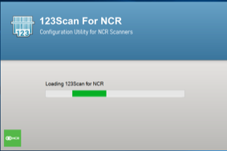

Configure the NCR 7895 using NCR 123Scan Utility
To configure the NCR 7895 scanner using 123Scan utility, follow these steps:
  - Connect 7895 Scanner/scale using RJ50 To Powered USB 12V Cable
Note: RJ50 will go into the POS port in the scanner/scale and USB end will go into the POS terminal.
  - Launch 123Scan for NCR Configuration Utility.
  - From Start page, click Create new configuration file. The application opens a new untitled tab and displays options in creating a configuration file.
  - When it asks for Select an option to start a configuration file, select My scanner is connected via USB cable. The application displays the list of detected scanners and their firmware plug-in options.
  - Click the plug-in option for your scanner to start the Configuration Wizard.
  - Set the configuration name.
  - On the left pane of the 123Scan Configuration Wizard, select Cable connection. The application displays the USB interface settings.
  - Keep USB as the cable and select “IBM Table Top USB” in USB Device Type.
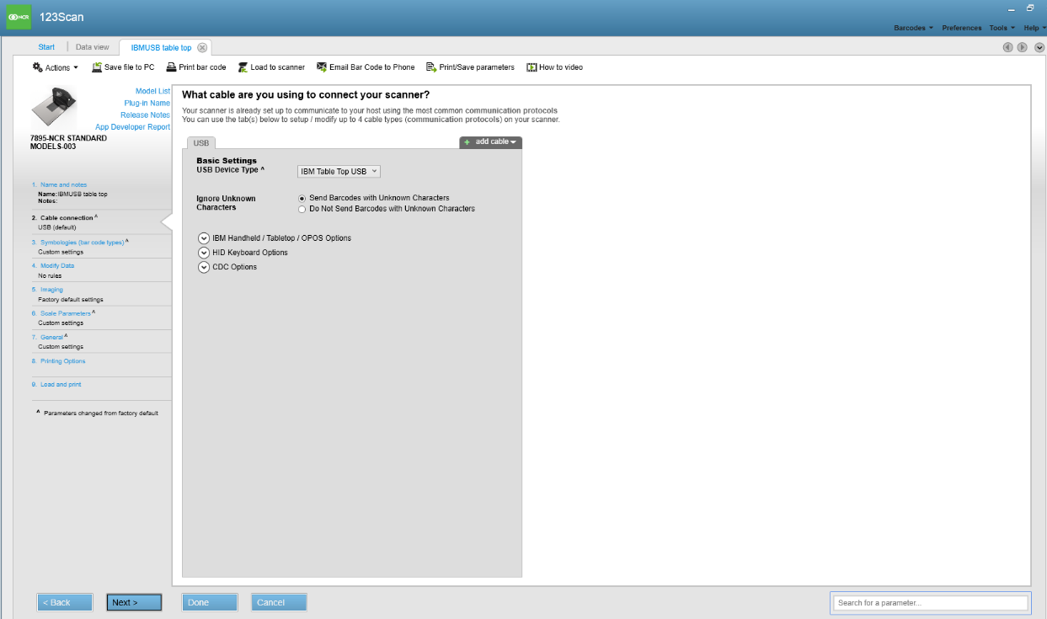
  - When finish, click Done
  - Once the file is created and configured, load the file to the scanner by clicking Load to Scanner option in the top bar.
The application displays the Load configuration window.
  - From the scanner list, select the scanner to configure. The application starts loading the configuration to the selected scanner. Select close.
  - Save by clicking Save file to PC in the top bar.
  - Close the 123Scan utility.
  - Open C:/Program files/Zebra technologies/Barcode scanners/Common>Config.xml file to make the following edit:
under:
<SIMULATED_HID_KB_SETTINGS>
Change the following setting to 1 from 0:
<Enable>1 </Enable>
  - Save the Config.xml file.
  - Turn off the scanner and disconnect the cable from the terminal.
  - Reboot POS terminal/workstation and reconnect the cable
  - Launch the 123Scan Utility.
  - Reload your configuration file created in above steps.
  - In Data view tab, click to select your scanner. This will open a screen to select an operation mode.
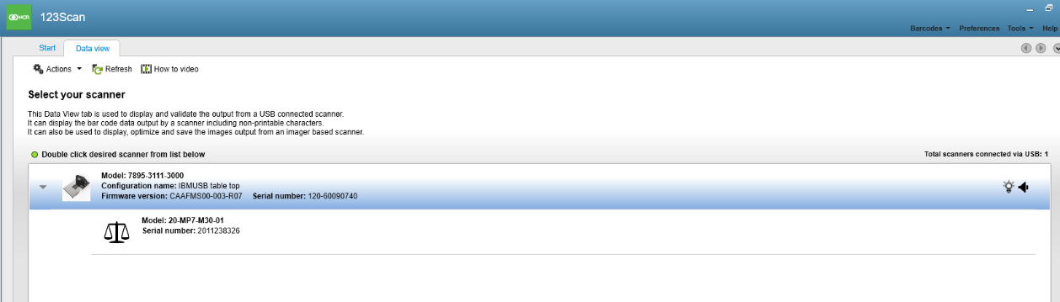
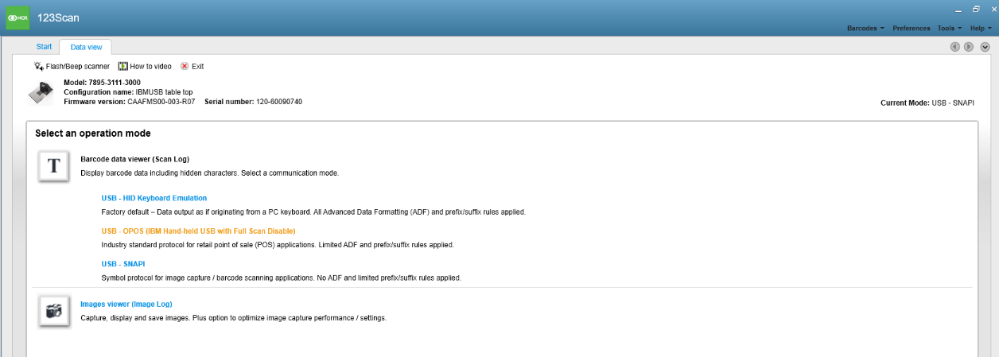
  - Under Select an operation mode, click to open “USB OPOS…” . This will open Scan log screen.
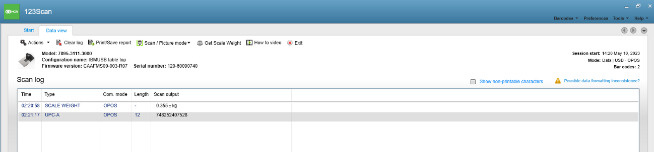
Verify scale and scanner works as desired:
- Scan the bar code of an item on the scanner/scale. This should add a row under the scan log as “OPOS” in Com. Mode and scan output showing the UPC bar code
- Keep the item on the scanner/scale and click “Get Scale Weight” in the top bar to weigh the item. This should add a row under the scan log as “OPOS” in Com. Mode and scan output showing the weight

Configure Scale Settings in Counterpoint
Follow these steps to configure you NCR 7895 Scanner/Scale in NCR Counterpoint:
- From the NCR Counterpoint main menu, select Setup > Point of Sale > Devices to display the Device Management window, and then expand the store to which the workstation you are configuring is assigned.
- Select the workstation you want to configure and click the Add a Device button.
- From the Add a Device menu, select Scales, and then select “Other OPOS Scale”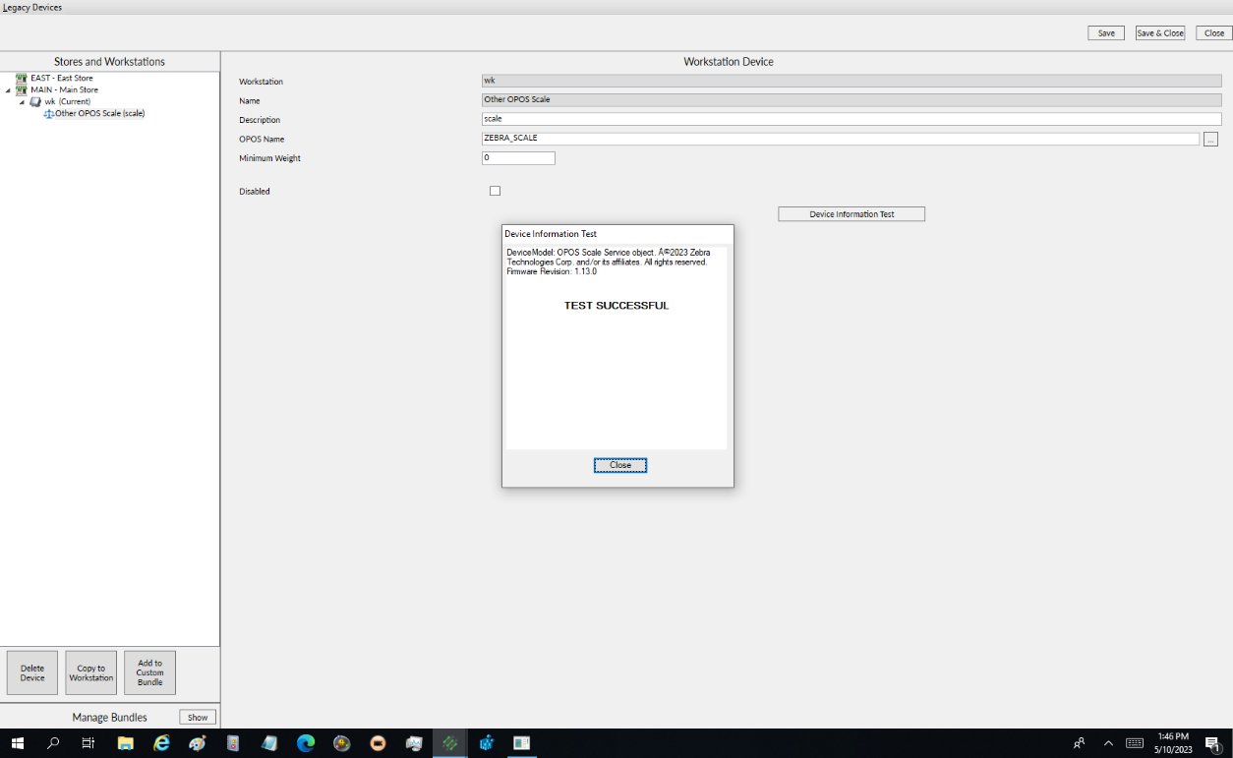.
- Click the button next to the OPOS Name field, select the “ZEBRA_SCALE”.
- Click Device Information Test button and test should be successful
If the test is unsuccessful, double-check the connection between the scale and your workstation, verify the configuration settings, and test the scale again.
If the test is successful, Save & Close.

Configure Scanner Settings
The NCR 7895 Scanner does not require any additional configuration in Counterpoint.

