How to set up a BOGO price rule / Buy 2 get the 3rd free – Using Mix and match code

NOTE: If a mix-and-match code is based on Total quantity, items in the mix-and-match group must be sold in the same unit (e.g., EACH, CASE, DOZEN, and so forth) in order to qualify for the mix-and-match price.

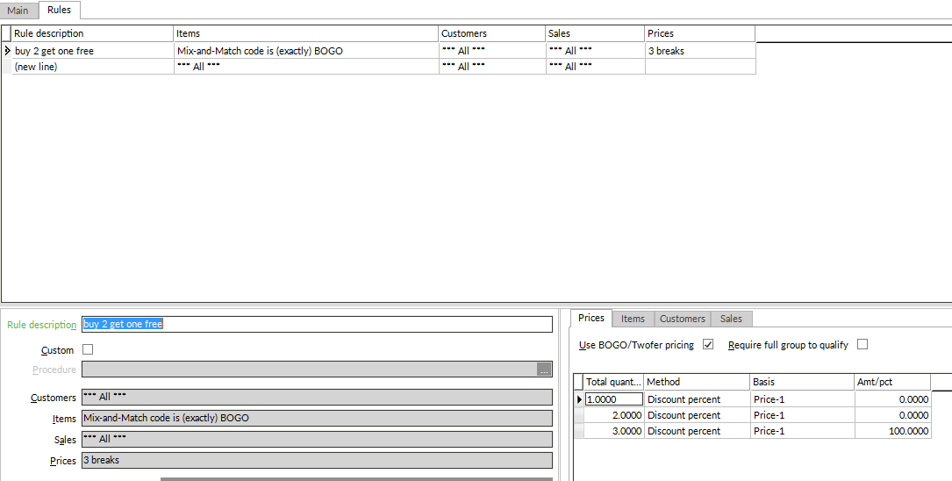
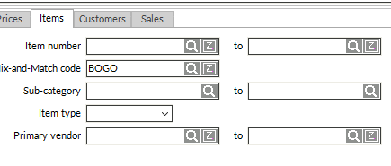
Applicable items:
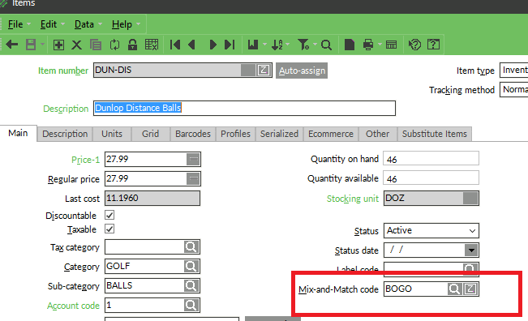
Result:



